Assignment 1 Web technology

during the first Assignment I decided to make an website which in which you would be able to type your groceries, remove groceries from your list and check them off if you had bought them in the supermarket.

The website is hosted at the following webpage:

<https://koalafabriek.github.io/>

I have tested the website using: Google Chrome, internet explorer, Microsoft edge, Mozilla firefox and opera.

I made my website by combining codes I found on the internet and a little bit of my own imagination, I did not use an front-end framework, and my website is responsive.

Now follows some screenshots.

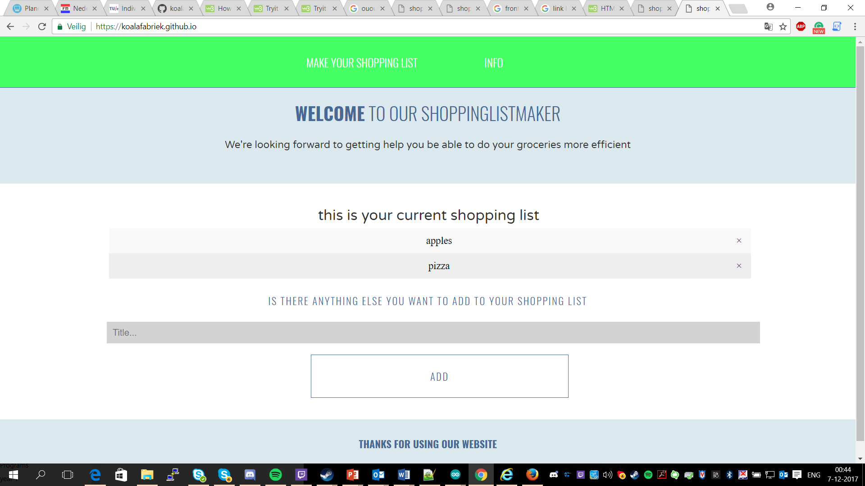

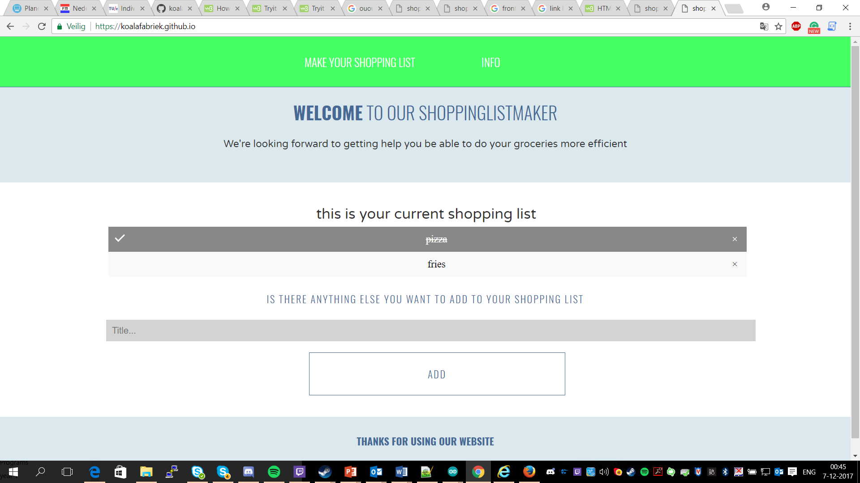

Difference between the screeshots, is that there is one element added, one element removed and one element checked.

With this website the user is able to keep an shopping list at his disposel, he can remove, add and check off thinks from his list, this is all done using javascript.